Learning Guide 4
2.3B Factors affecting the rate of dissolving
Name: ____________________
Class: __________ ( ) Date: ____________________

Dictionary
(with pronunciation)
Objectives:
Knowledge: Recognize the factors affecting the rate of dissolving.
Skill: Perform fair tests to study the factors affecting the rate of dissolving.
Use AI as a Data Analyst to evaluate data reliability and error sources.
Attitude: Take ownership of learning by predicting, verifying, and using AI coaching to deepen scientific reasoning.

 Keywords
- Underline the vowels (a, e, i, o, u) and break up the words into syllables (only for the first word).
- Check the dictionary/textbook and write the Chinese meaning of the words in the brackets provided.
- Review the keywords and prepare for dictation.

Factors affecting the rate of dissolving | Diagrams
- size (noun) (大小) | /
- volume (noun) (體積) | /
- temperature (noun) (溫度) | /
- mass (noun) (質量) | /
- stir (verb) (攪拌) | 
- increase (verb) (上升) | 
- decrease (verb) (下降) | 
Hints: 大小、溫度、體積、上升、下降、攪拌、質量
Preparation Questions
(Read textbook P.95–100 and answer the following questions)
(Check the Chinese meaning of the words highlighted before lesson)

Think-pair-share The Morning Drink
Q1. Think: You are making a a cup of hot milk tea. You want to dissolve sugar faster. What can you do?
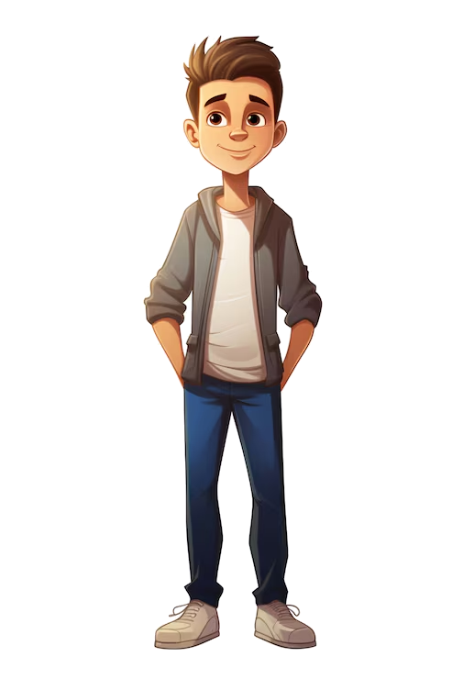
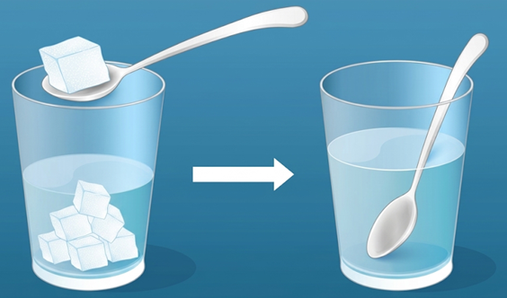
I can dissolve the sugar quicker by ______________________________
______________________________



Pair: Pair-up with your groupmates and share your thoughts.
Share: Discuss your methods with whole class.

Language Support:

If we say something dissolves faster, that means it has a higher rate of dissolving.

Pre-lab Session
Q2. We are going to carry out fair tests to study how volume of water affect the rate of dissolving.
Complete the table below.
Hypothesis | The rate of dissolving of sugar in water increases (increases / decreases) if more water is used.
Variable to be changed | Volume of water
Variables to me compared | Time needed for the sugar to completely dissolve in water
Variables to be kept constant  (Put “” in the box(es)) | ☑ Temperature of water   Volume of water  ☑ Mass of sugar  ☑ Size of sugar pieces

 Experiment Time: Experiment 2.5 – Factors affecting the rate of dissolving

Step 1 | Prepare 50 cm³, 100 cm³, 150 cm³ and 200 cm³ of water in four beakers of the same size.
  
  50 cm³ | 100 cm³ | 150 cm³ | 200 cm³
Step 2 | 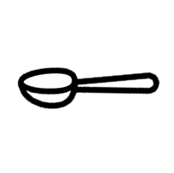    Add a spatula of sugar and start the stopwatch. Stir the liquid with a glass rod until all sugar dissolved.  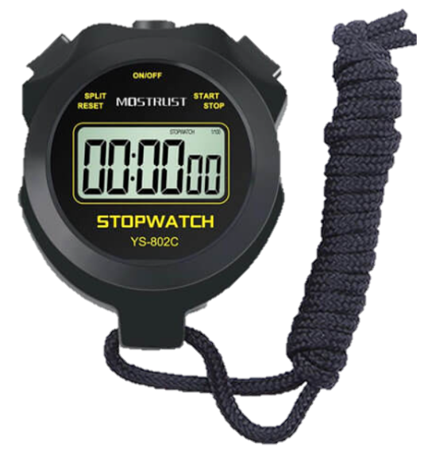  
Step 3 | Record the time taken for all the sugar dissolved.

Results:
Volume of water | 50 cm³ | 100 cm³ | 150 cm³ | 200 cm³
Time needed for the sugar to completely dissolve in water | __________ s | __________ s | __________ s | __________ s

Input your data into Agent Water. He may ask you some interesting questions. Try to answer him and record what you have learnt through the conversation.
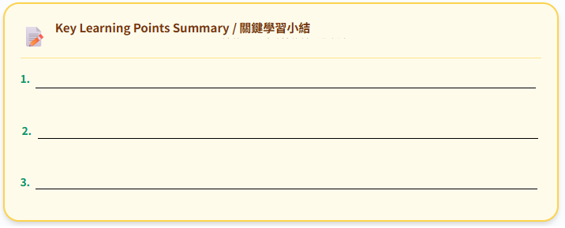
High-order thinking questions:
Q1. Why do we take average (取平均數) of eight groups of the reading?
To reduce random errors – the results are more reliable.

Q2. Suggest limitations of this experiment and some methods to make the results more reliable.
- Limitation: human error in manual stirring
Improvement: let the same person stir the solution // use magnetic stirrer
- Limitation: subjective judgment of dissolving endpoint
Improvement: let the same person decide the endpoint // use digital light/turbidity sensors
- Limitation: stopwatch reaction time lag
Improvement: video recording the experiment for timestamping

Conclusion:
Sugar dissolves faster (faster / slower) if more volume of water is used.

Extension:
The rate of dissolving depends on many other factors. Try to design and carry out fair tests to study how different factors affect the rate of dissolving.

Factors | Comparison |  |  | Checklist
Volume of water | more water | V.S. | less water | ☑ | (Done in this lesson)
Stirring | stirred | V.S. | not stirred | 
Size of the solute pieces | powdered sugar | V.S. | sugar cube | 
Temperature | hot water | V.S. | cold water | 

